Install the Apache Drill environment. If you are on windows, you can follow the instructions in the video below.

<https://www.youtube.com/watch?v=jDio1Dd8q2g>

Once successfully installed…

## Launching drill

<https://drill.apache.org/docs/starting-drill-on-windows/>

> cd Drill\apache-drill-1.16.0\bin

> drill-embedded.bat (if using Drill 1.16 and later.)

## Testing drill installation

Check specs

> SELECT hostname FROM sys.drillbits WHERE `current` = true;

> SELECT version FROM sys.version;

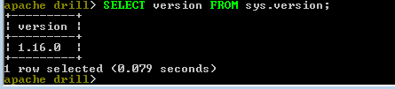

You can run a test query to verify that Drill is running using sample data downloaded with Drill

Drill's classpath contains sample data, including an employee.json file that you can query. Switch schema to cp, for classpath.

> use cp;

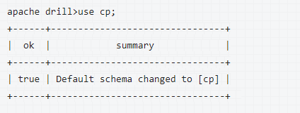

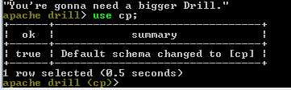

Query the employee.json file in the classpath.

* SELECT * FROM cp.`employee.json` LIMIT 1;

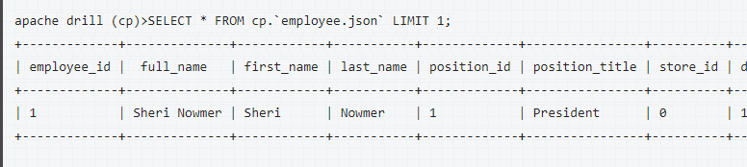

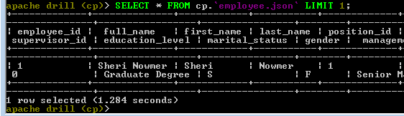

OR if you don’t want to issue the command use cp;

* SELECT * FROM cp.`employee.json` LIMIT 1;

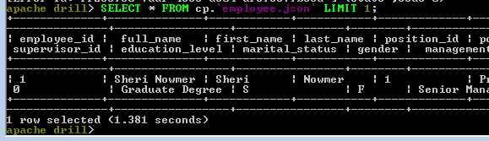

From the web browser

### Web browser

<http://localhost:8047/query>

Submit or Ctrl+Enter yields

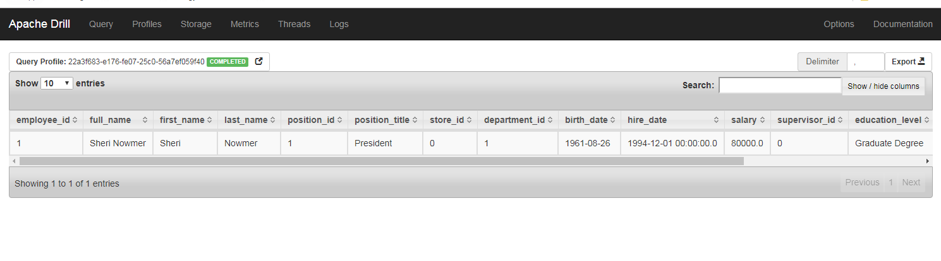

## Exit drill

* !quit

## Read parquet

Before moving to create a table in parquet, you must change the Drill storage format using the following command.

> alter session set `store.format`= 'parquet';

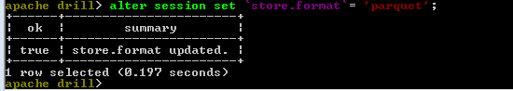

> SELECT * FROM dfs.`Drill/apache-drill-1.16.0/sample-data/region.parquet`;

Note: need to use ` vs. ‘ This symbol is the key with the tilda at top left of keyboard vs. the single quote mark. 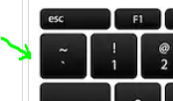 vs. 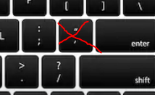

> SELECT * FROM dfs.`Drill/apache-drill-1.16.0/sample-data/nation.parquet`;

## Connecting to Tableau

### Installing driver

Follow instructions for installing the Drill OBDC Driver if needed (Request to User Services Center to get Admin Rights for install): <https://drill.apache.org/docs/installing-the-driver-on-windows/>

If you need to configure anything, follow this: <https://drill.apache.org/docs/configuring-odbc-on-windows/>

Search obdc and select Set up data sources (ODBC)

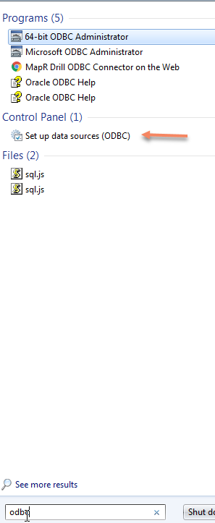

Select Systems DSN, MapR Drill, Configure

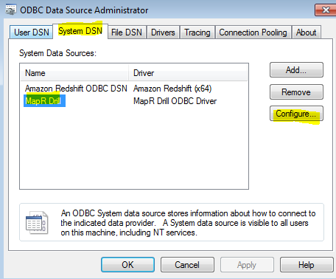

Configuration window should open. You can test it but clicking the Test button at bottom of dialog box.

Or you can launch the Drill Explorer…

Drill Explorer will look something like this. The section below details how to create dfs.donuts.

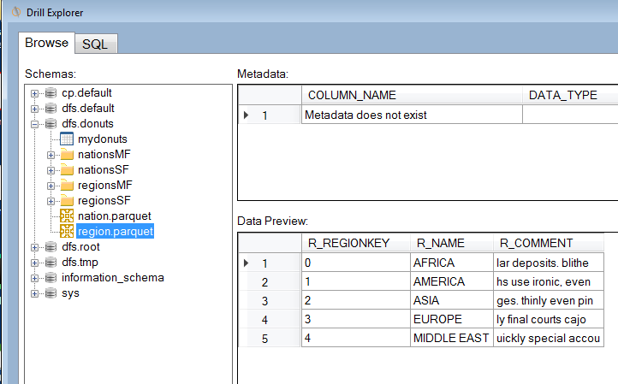

### Creating a Workspace

Tableau or other BI tools will not find the schemas on file system. So to get tables list in Tableau you need to create Workspaces and Drill views on MapR file system data using CREATE VIEW

<https://mapr.com/community/s/question/0D50L00006BItgPSAT/tableau-over-drill-on-dfs>

<https://drill.apache.org/docs/create-view/>

*The example below creates a Workspace named* ***donuts*** *and creates a View called* ***mydonuts****. Drill’s sample parquet file (Drill/apache-drill-1.16.0\sample-data/region.parquet) is used for the underlying data*.

In cmd, connect to Drill

(This can also be done from Drill Explorer <https://drill.apache.org/docs/browsing-data-and-defining-views/>)

> cd Drill\apache-drill-1.16.0\bin

> drill-embedded.bat

See existing schema/databases (**NOTE**: *screen shot shows dfs.donuts which you will not see by default, but we will create it*)

> show databases;

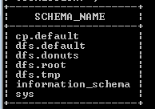

Workspace we will create

In web browser, go to: <http://localhost:8047/storage>

Click on the Update button by dfs

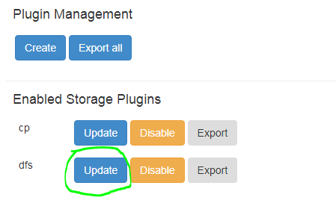

Under workspaces add the following (changing the location to point to where the region.parquet files are on your machine (<https://drill.apache.org/docs/workspaces/>):

"donuts": {

"location": "/Users/user1/donuts",

"writable": true,

"defaultInputFormat": null

},

Click the Update button at bottom of Configuration box

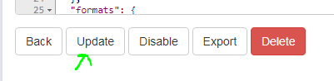

Go back to your cmd prompt

> show databases;

You should now see dfs.donuts

Switch schema to dfs.donuts

> use dfs.donuts;

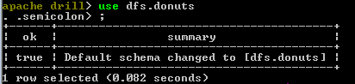

Query regions.parquet

> SELECT * FROM `region.parquet`;

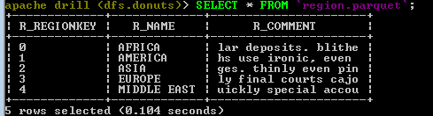

Run the CREATE VIEW command with the query.

> CREATE VIEW mydonuts AS SELECT * FROM `region.parquet`;

Query the view created

> SELECT * FROM mydonuts;

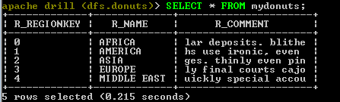

You are now ready to connect to Tableau

(Note: You can create a new view in another workspace that is not the current workspace. See <https://drill.apache.org/docs/create-view/>)

If you later decide you do not want mydonuts: <https://drill.apache.org/docs/drop-view/>

> DROP VIEW mydonuts;

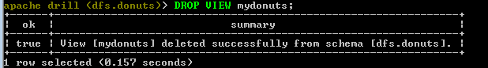

### Connecting

Follow instructions for connection Tableau to Drill: <https://help.tableau.com/current/pro/desktop/en-us/examples_apachedrill.htm>

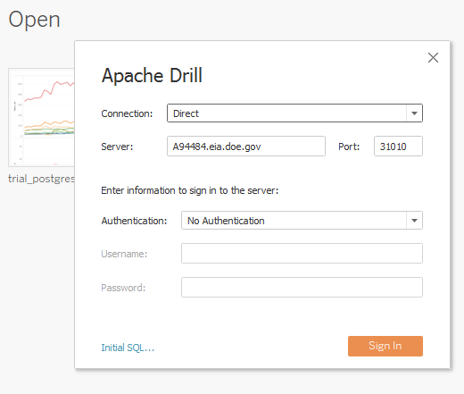

Once you are connected, click the drop down menu under Schema and select dfs.donuts

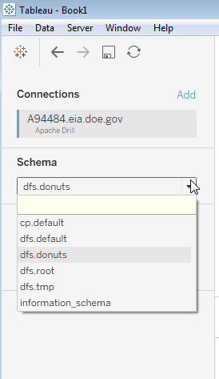

Table options should appear below that show mydonuts

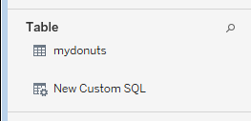

Select mydonuts (double click)

In Display box (to the right), select Update Now to display table in Tableau.

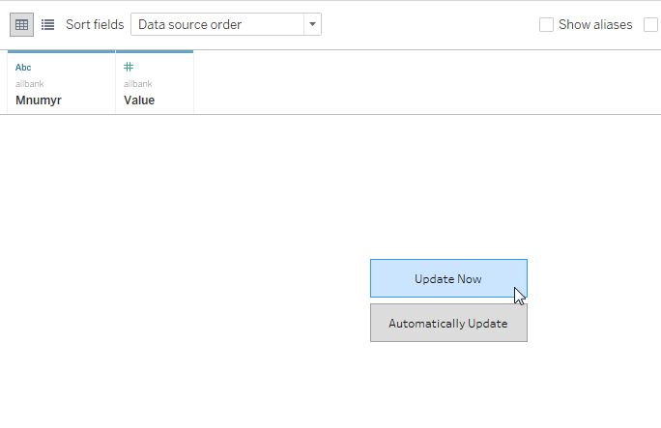

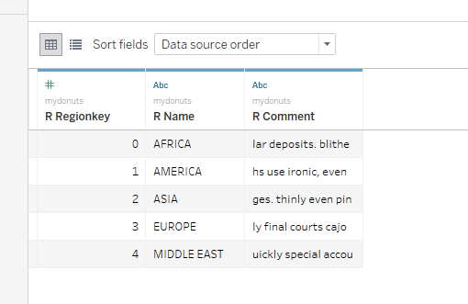

Additional help: <https://drill.apache.org/docs/using-apache-drill-with-tableau-10-2/>

Other commands

Switch schema to a Workspace

> use dfs.donuts;

> show files;

This will show any views created (see screen shot below)

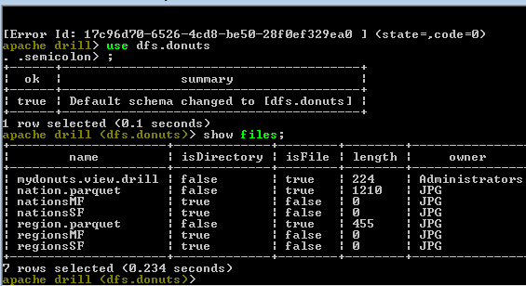

If you DROP VIEW mydounts;

